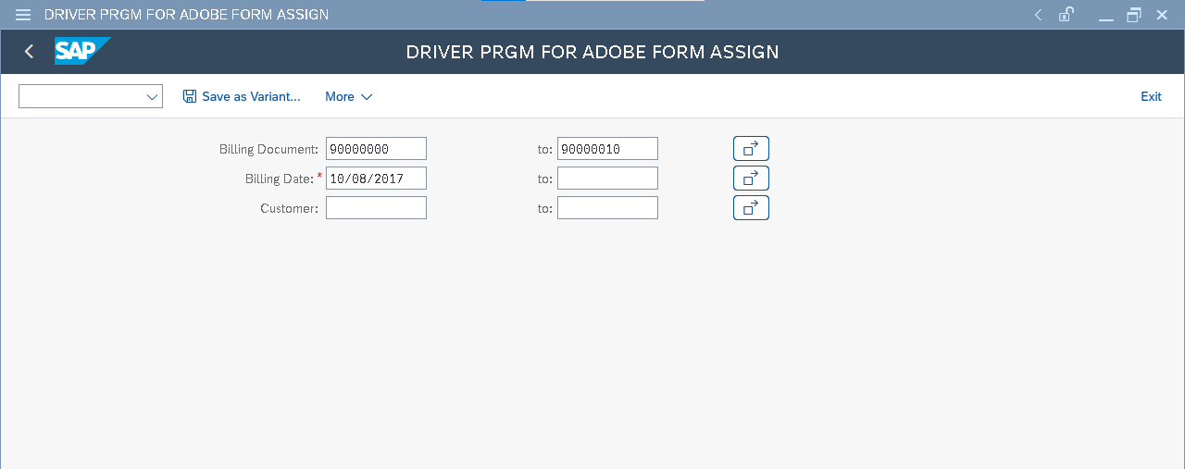

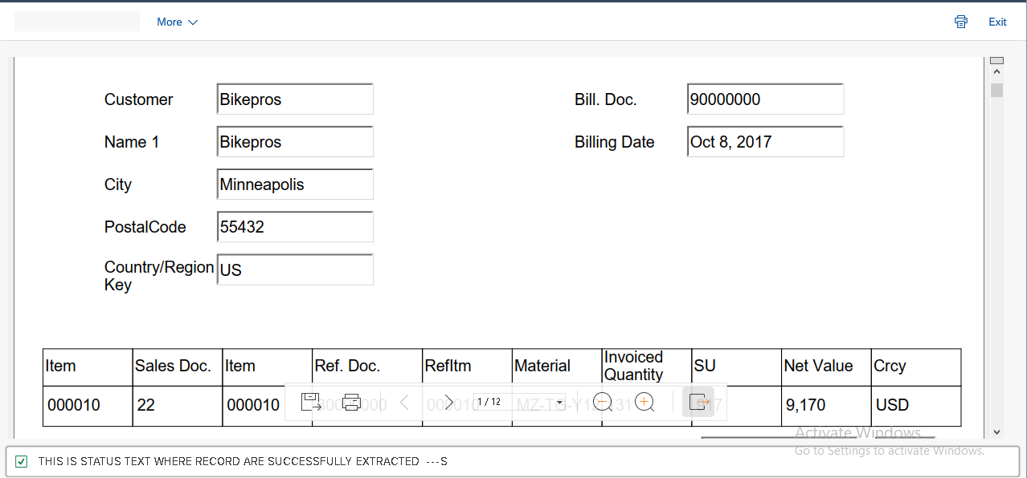

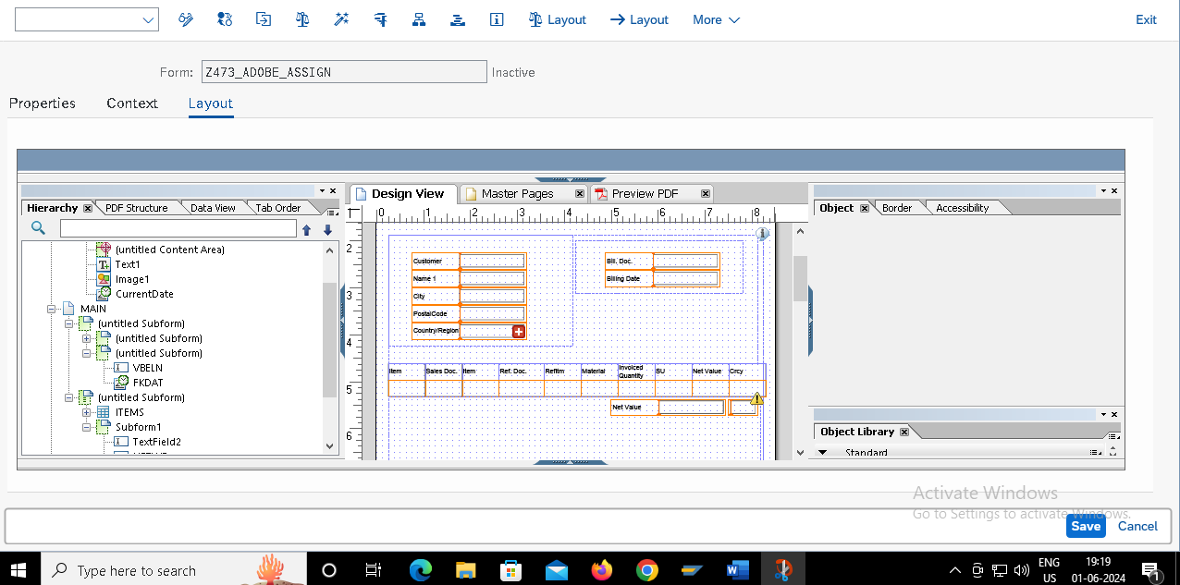

PROGRAM:

REPORT Z473_FORM_ADOBE_ASSIG.

INCLUDE Z473_FORM_TOP_INCL.

include Z473_FORM_INCL_MAIN.

START-OF-SELECTION.

INCLUDE Z473_MAIN_LOGIC_INCL.

INCLUDE Z473_MAIN_LOOP_FINAL_INCL.

INCLUDE Z473_FUN_INCL.